**1. To change the Font Size And Colour**

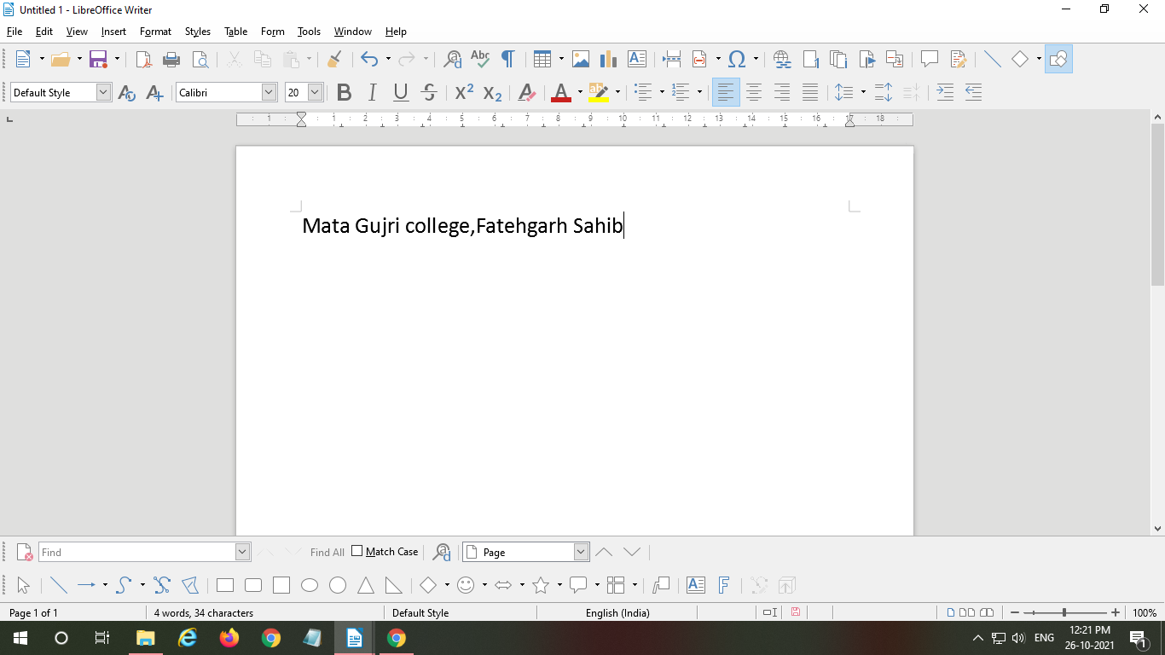

**To change Font Size:**

1. Select the text for which to change the text size.
2. Go to Standard toolbar
3. Click on font size
4. Change The Font Size

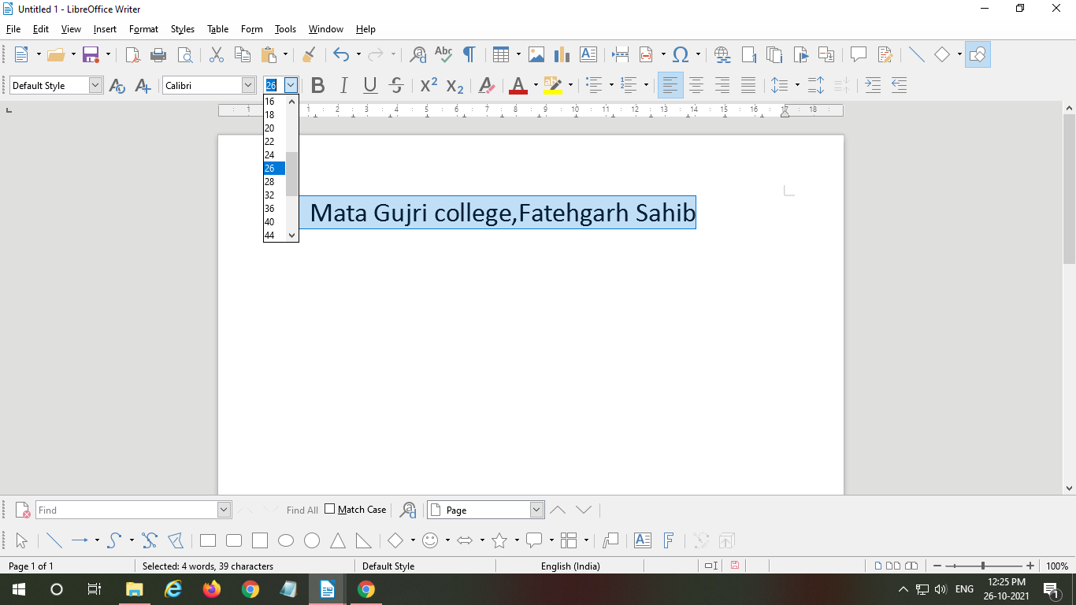

**To Change Font Colour:**

1. Go to Standard tool bar
2. Click on Font Color
3. Select Your Desired Color

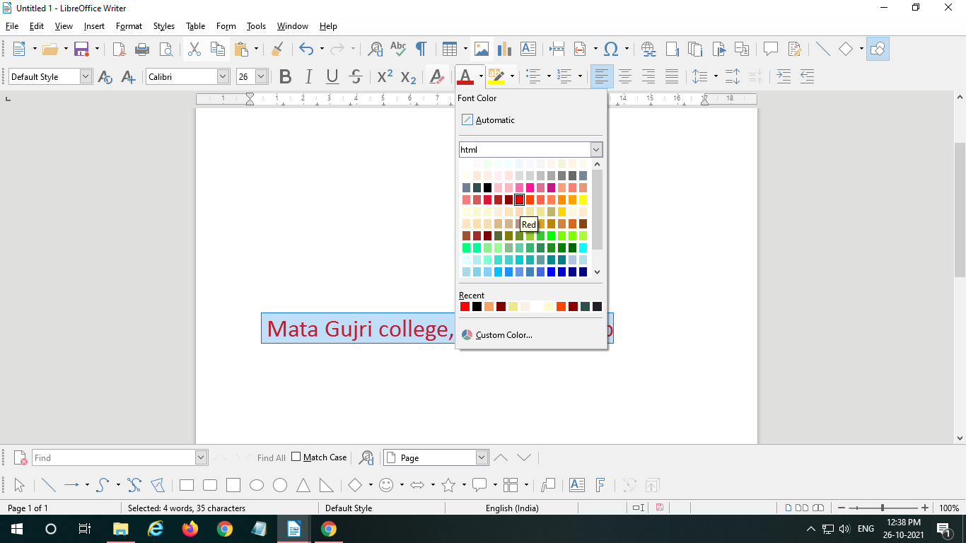

**2. To Use DropCap And WordArt**

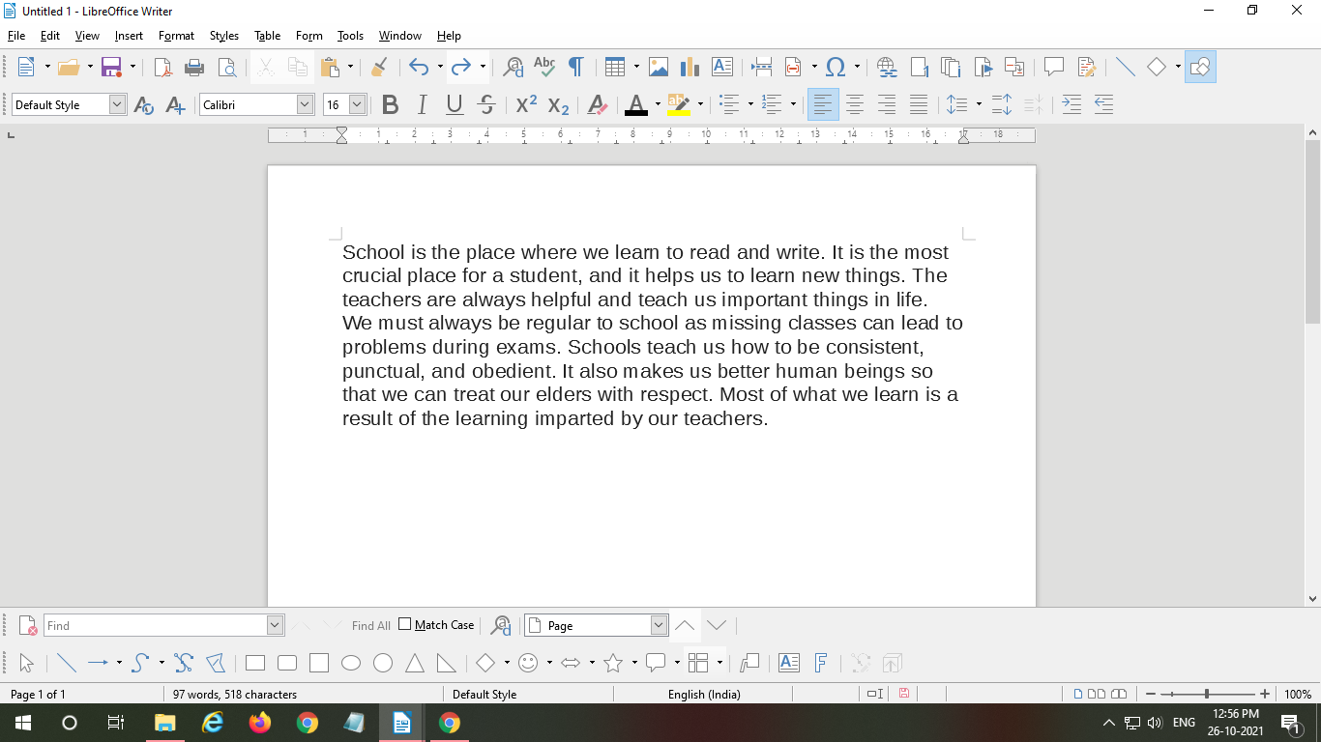

Steps:-

1. Select the text and right click

2. Click on Paragraph and Again Click on Paragraph

3. Now Select Dropcaps

4.

